# OODP workshop 4

1. What are different types of loops in java? Explain each of them with proper syntax.
2. Write a program to ask the user to enter a number and print count down from that number to 0.
3. Write a program to ask user to enter the temperature of seven days and then find out the average temperature and print the results.
4. Write a program to ask user a value and make sure that value is between 3 and 6 inclusive. Keep asking the user until user enters a valid value and display a success message and print error when user enter invalid value.

**1. Ans:**

Different types of loops in Java with explanations and proper syntax:

1. for loop: The for loop is the most commonly used loop in Java. It is used to iterate over a block of code a specified number of times. It has three parts: initialization, condition, and iteration.

Syntax:

for (initialization; condition; iteration) {

*// code to be executed*

}

Example:

for (int i = 0; i < 5; i++) {

System.out.println("Value of i: " + i);

}

1. while loop: The while loop is used to execute a block of code repeatedly as long as a given condition is true.

Syntax:

while (condition) {

*// code to be executed*

}

Example:

int count = 0;

while (count < 5) {

System.out.println("Count: " + count);

count++;

}

1. do-while loop: The do-while loop is similar to the while loop, but it guarantees that the code block will execute at least once before checking the condition.

Syntax:

do {

*// code to be executed*

} while (condition);

Example:

int num = 10;

do {

System.out.println("Number: " + num);

num++;

} while (num < 5);

1. for-each loop (Enhanced for loop): The for-each loop is used to iterate over the elements of an array or a collection (like ArrayList) in a compact and readable way.

Syntax:

for (dataType element : array/collection) {

*// code to be executed*

}

Example:

int[] numbers = {1, 2, 3, 4, 5};

for (int num : numbers) {

System.out.println("Number: " + num);

}

1. Nested loops: Loops can be nested within other loops in Java. This means that one loop can be placed inside the body of another loop. Nested loops are useful when you need to iterate over two or more collections or perform operations on multi-dimensional arrays.

Example:

for (int i = 1; i <= 3; i++) {

for (int j = 1; j <= 3; j++) {

System.out.println("i: " + i + ", j: " + j);

}

}

These are the main types of loops in Java.

**2. Ans: Count-Down Program**

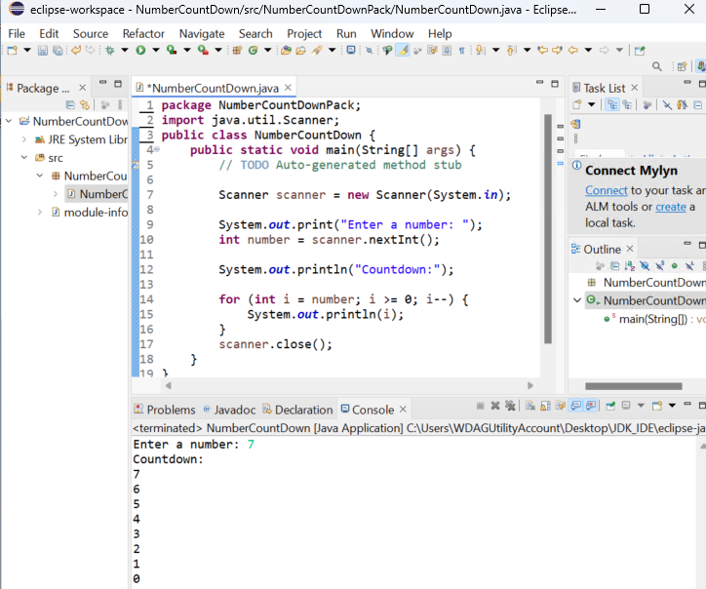

**3.Ans:**

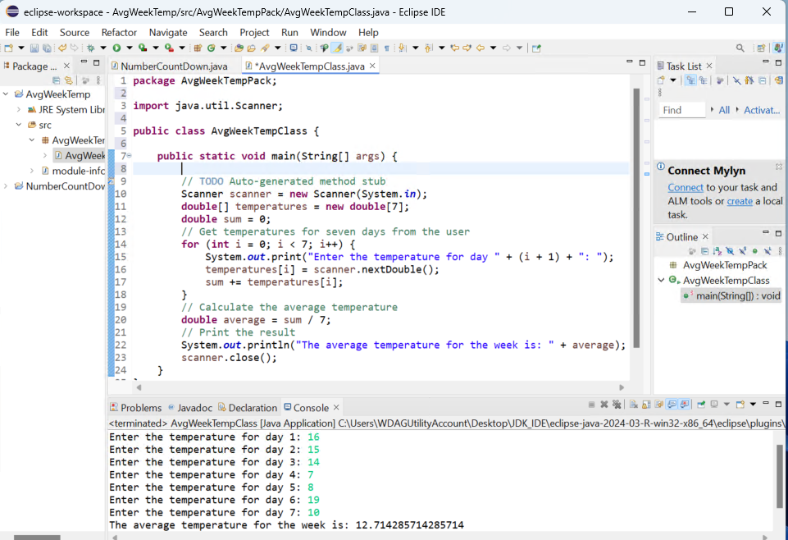

(Continue to page 4)

**4.Ans**

